#### Authentication

We use API key authentication.

You need get token in our site:

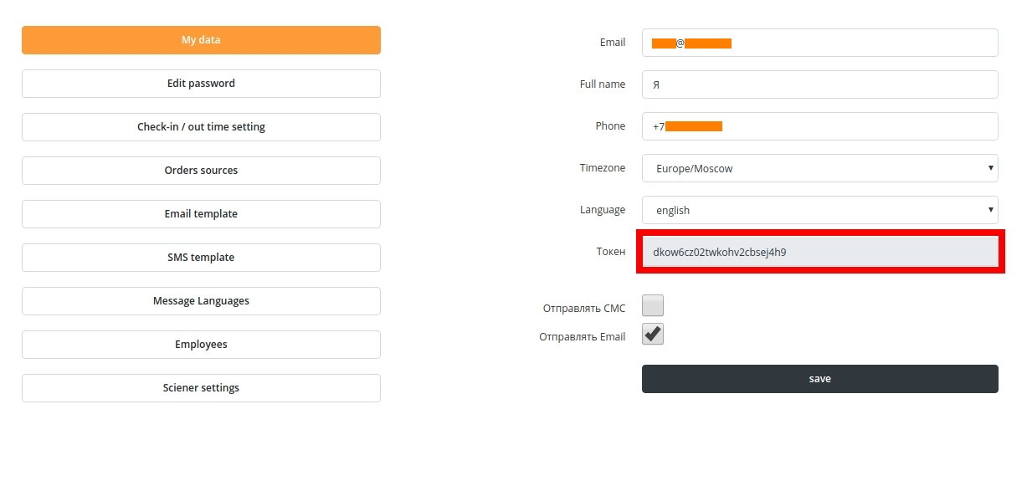

And put it in Zapier authentication

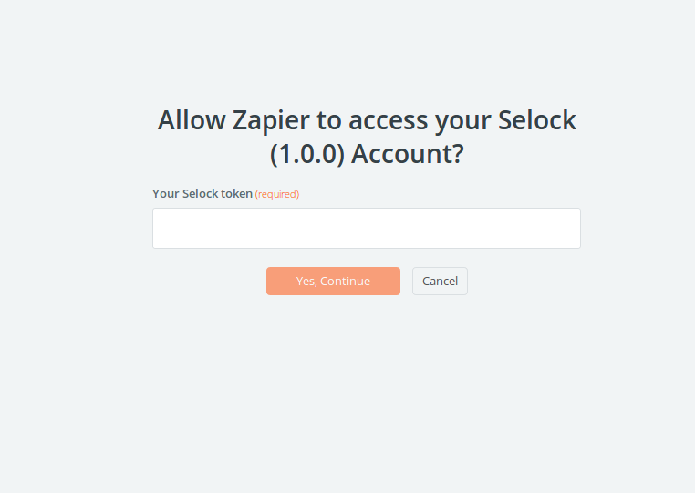

We await token in url <https://selock.co/api/v1/zaiper/auth/> in body 'token': <token>

Triggers

Battery

*It triggered when the battery charge drops below 20%*

**Subscribe:**

<https://selock.co/api/v1/zaiper/subscribe/battery/>

### **Unsubscribe:**

https://selock.co/api/v1/zaiper/unsubscribe/battery/

With your Selock token in body

Locks

*It triggered when Sciener sends a lock status change callback*

**Subscribe:**

[https://selock.co/api/v1/zaiper/subscribe/locks/](https://selock.co/api/v1/zaiper/subscribe/battery/)

### **Unsubscribe:**

https://selock.co/api/v1/zaiper/unsubscribe/locks/

With your Selock token in body

Locks open

*It triggered when Sciener sends a lock status change callback with success open*

**Subscribe:**

[https://selock.co/api/v1/zaiper/subscribe/locks_open/](https://selock.co/api/v1/zaiper/subscribe/battery/)

### **Unsubscribe:**

https://selock.co/api/v1/zaiper/unsubscribe/locks_open/

With your Selock token in the body

Locks close

*It triggered when Sciener sends a lock status change callback with success close*

**Subscribe:**

[https://selock.co/api/v1/zaiper/subscribe/locks_close/](https://selock.co/api/v1/zaiper/subscribe/battery/)

### **Unsubscribe:**

https://selock.co/api/v1/zaiper/unsubscribe/locks_close/

With your Selock token in the body

New Orders

*It triggered when a new order is created for the Selock*

**Subscribe:**

[https://selock.co/api/v1/zaiper/subscribe/orders/](https://selock.co/api/v1/zaiper/subscribe/battery/)

### **Unsubscribe:**

https://selock.co/api/v1/zaiper/unsubscribe/orders/

With your Selock token in the body

Orders change

*It triggered when an order for the Silok changes*

**Subscribe:**

[https://selock.co/api/v1/zaiper/subscribe/orders_change/](https://selock.co/api/v1/zaiper/subscribe/battery/)

### **Unsubscribe:**

https://selock.co/api/v1/zaiper/unsubscribe/orders_change/

With your Selock token in the body

Actions

Change Status

*Changes lock status*

**url*:***

https://selock.co/api/v1/zaiper/change_lock_status/

**await in the body:**

token – your Selock token (required)

status – close or open (example: “open”) (required)

lock_id – Sciener lock ID (example: “1234567”) (required)

Change Order

*Changes your Selock order*

**url*:***

https://selock.co/api/v1/zaiper/change_order/

**await in the body:**

token – your Selock token (required)

order_id – Selock order ID (example: 123) (required)

start_date – order start date (example: “29-10-2020”)

hour_in – order arrival hour (example: 14)

end_date – order end date (example: “30-10-2020”)

hour_out – order departure hour (example: 12)

room_id – Selock room ID (example: 321)

comment – your comment on the order (example: “order from a friend”)

price – order price (example: 1000)

paid – paid order price (example: 500)

confirmed – order confirmed status (example: true)

busy – order busy status (example: true)

completed – order busy status (example: false)

canceled – order busy status (example: false)

language – order language.

This is the name of the language from your Selock account (example: “русский”)

source – order source.

This is the title of the source from your Selock account (example: “direct sale”)

Create Order

*Changes your Selock order*

**url*:***

https://selock.co/api/v1/zaiper/create_order/

**await in the body:**

token – your Selock token (required)

guest_name – Guest name of this order (example: “Ivan”) (required)

guest_surname – Guest surname of this order (example: “Ivanov”)

guest_phone – Guest phone of this order (example: “79012345678”) (required)

guest_email – Guest email of this order (example: “ivanivanov@mail.ru”)

start_date – order start date (example: “29-10-2020”) (required)

hour_in – order arrival hour (example: 14)

end_date – order end date (example: “30-10-2020”) (required)

hour_out – order departure hour (example: 12)

room_id – Selock room ID (example: 321) (required)

comment – your comment on the order (example: “order from a friend”)

price – order price (example: 1000)

paid – paid order price (example: 500)

confirmed – order confirmed status (example: true)

busy – order busy status (example: true)

completed – order busy status (example: false)

canceled – order busy status (example: false)

language – order language.

This is the name of the language from your Selock account (example: “русский”)

source – order source.

This is the title of the source from your Selock account (example: “direct sale”)